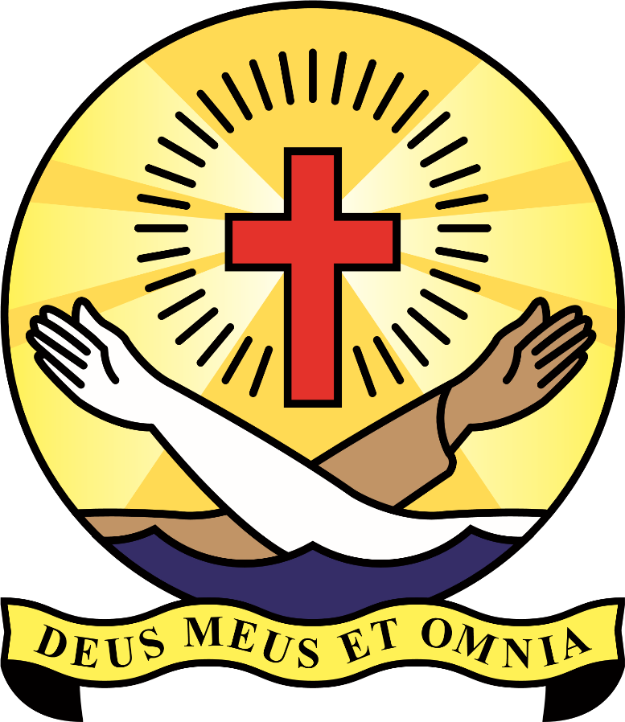
Information on St. Clare’s College
School History

In February 1872, four sisters of St. Clare arrived in Ballyjamesduff to open a school for girls at the request of Bishop Conaty. The Sisters were members of the Order founded in Assisi centuries earlier by St. Francis and St. Clare. For almost one hundred years the Sisters of St. Clare’s provided primary education for the girls in Ballyjamesduff. This work expanded in 1962 when Bishop Austin Quinn asked the Sisters to open a secondary school for girls. From an initial enrolment of seventy one pupils in 1964, student numbers increased steadily. In 1972, it was felt that boys from the area should have an opportunity to be educated in their own community and in consultation with Bishop Austin Quinn, St. Clare’s became co-educational and the curriculum was widened.
As student numbers continued to grow there was a need to build a new school. In 1976, the Department agreed to pay 80% of the cost of building and equipping a modern college in Ballyjamesduff. A key principle of the rule of St. Clare is the concept of service and the desire to be free of ownership of property. Consequently, the Sisters of St. Clare’s decided to hand over the school to the Diocese of Kilmore and to be available to serve the community of Ballyjamesduff as needed. They provided a site free of change and Bishop McKiernan agreed to accept responsibility for the remaining 20% of the cost involved in the project. This decision assured the continued existence of a Catholic Post Primary School in Ballyjamesduff.
The new College opened its doors to students in September 1982, with the help of a dedicated staff and great support from parents and the local community. Under the new patronage of the diocese of Kilmore, St. Clare’s College became a diocesan school.
Today
In it sixtieth year as a secondary school in Ballyjamesduff, St. Clare’s College has continued to grow and flourish. With an enrolment of six hundred and twenty three students, there has been a need to extend our curriculum and add to our facilities. In September 2022, St. Clare’s College has been sanctioned a major new extension which will further enhance our provision of quality learning and teaching.
As a Catholic diocesan school, we remain committed to:
- Promoting the holistic development of each member of the school community including the spiritual, moral, emotional, social and human aspects
- Striving to excel in teaching and learning both inside and outside the classroom
- Creating a caring school community that celebrates its diversity and keeps partnership and inclusion at the centre of all of its activities
- Encouraging effective leadership, especially Christian leadership, at all levels
- Continuing the ministry of Christ through nurturing a faith community in the traditions of our diocese
St. Clare’s College remains committed to the vision of the Sisters of St. Clare- to bring service to the community.

